UNITED STATES
SECURITIES AND EXCHANGE COMMISSION
Washington, DC 20549
FORM 8-K
CURRENT REPORT
Pursuant to Section 13 OR 15(d) of the
Securities Exchange Act of 1934
Date of Report (Date of earliest event reported): May 19, 2026
Carlyle Credit Income Fund
(Exact name of registrant as specified in its charter)
Delaware |  | 811-22554 |  |  | 45-2904236
(State or Other Jurisdiction  of Incorporation) |  | (Commission  File Number) |  |  | (IRS Employer  Identification No.)
One Vanderbilt Avenue, Suite 3400
New York, New York 10017
(Address of Principal Executive Offices, Zip Code)
(212) 813-4900
(Registrant’s Telephone Number, Including Area Code)
Not Applicable
(Former Name or Former Address, if Changed Since Last Report)
Check the appropriate box below if the Form 8-K filing is intended to simultaneously satisfy the filing obligation of the registrant under any
of the following provisions (see General Instruction A.2. below):
☐ | Written communications pursuant to Rule 425 under the Securities Act (17 CFR 230.425)
☐ | Soliciting material pursuant to Rule 14a-12 under the Exchange Act (17 CFR 240.14a-12)
☐ | Pre-commencement communications pursuant to Rule 14d-2(b) under the Exchange Act (17 CFR 240.14d-2(b))
☐ | Pre-commencement communications pursuant to Rule 13e-4(c) under the Exchange Act (17 CFR 240.13e-4(c))
Securities registered pursuant to Section 12(b) of the Act:
Title of each class | Trading Symbol(s) | Name of each exchange on which registered
Common Shares | CCIF | New York Stock Exchange
Preferred Shares | CCID | New York Stock Exchange
Indicate by check mark whether the registrant is an emerging growth company as defined in Rule 405 of the Securities Act of 1933 (§230.405
of this chapter) or Rule 12b-2 of the Securities Exchange Act of 1934 (§240.12b-2 of this chapter).
Emerging growth company ☐
If an emerging growth company, indicate by check mark if the registrant has elected not to use the extended transition period for complying
with any new or revised financial accounting standards provided pursuant to Section 13(a) of the Exchange Act. ☐
Item 2.02 – Results of Operations and Financial Condition.
On May 19, 2026, Carlyle Credit Income Fund (the “Fund”) issued a summary press release and a detailed earnings
presentation announcing its second quarter 2026 financial results. Copies of the summary press release and the earnings
presentation are attached hereto as Exhibit 99.1 and Exhibit 99.2, respectively.
The information disclosed under this Item 2.02, including Exhibits 99.1 and 99.2 hereto, is being furnished and shall not be
deemed “filed” for purposes of Section 18 of the Securities Exchange Act of 1934 (the "Exchange Act"), and shall not be
deemed incorporated by reference into any filing made under the Securities Act of 1933 (the "Securities Act") or the
Exchange Act, except as expressly set forth by specific reference in such filing.
Item 9.01 – Financial Statements and Exhibits.
Exhibits 99.1 and 99.2 shall be deemed furnished herewith.
(d)Exhibits:
Exhibit Number |  | Description
99.1 |  | Summary earnings press release of Carlyle Credit Income Fund, dated March 31, 2026.
99.2 |  | Earnings presentation of Carlyle Credit Income Fund, dated March 31, 2026.
104 |  | Cover Page Interactive Data File (embedded within the Inline XBRL document).
SIGNATURES
Pursuant to the requirements of the Securities Exchange Act of 1934, the Registrant has duly caused this report to be signed on
its behalf by the undersigned hereunto duly authorized.
 |  |  |  | CARLYLE CREDIT INCOME FUND
 |  |  |  | (Registrant)
Dated: May 19, 2026 |  | By: |  | /s/ Nelson Joseph
 |  |  |  | Name: Nelson Joseph
 |  |  |  | Title: Principal Financial Officer
Page | 1

Exhibit 99.1

Carlyle Credit Income Fund Announces Second Quarter Financial Results and Declares Monthly Common and
Preferred Dividends
New York – May 19, 2026 - Carlyle Credit Income Fund (“we,” “us,” “our,” “CCIF” or the “Fund”) (NYSE: CCIF) today
announced its financial results for its second quarter ending March 31, 2026. The full detailed presentation of the Fund’s second
quarter 2026 financial results can be viewed on the Fund’s website (https://www.carlylecreditincomefund.com/investor-
dashboard).
“In the second quarter, we remained focused on long-term value creation amid continued volatility across the CLO equity
market,” said Nishil Mehta, CCIF’s Principal Executive Officer and President. “While elevated repricing activity and weakness
in the loan market continued to pressure CLO equity cash flows and valuations during the quarter, underlying credit
fundamentals across the portfolio remained resilient. We maintained our monthly dividend of $0.06 per share, which we believe
remains well supported by core net investment income. During the quarter, we continued to reset CLOs within the underlying
portfolio, extending reinvestment periods and lowering financing costs. Looking ahead, we remain focused on disciplined
underwriting, active portfolio management, and investing alongside experienced CLO managers as we seek to capitalize on
opportunities created by market volatility.”
Over the past quarter, the Fund has successfully
•Declared a monthly dividend of $0.06 cents through August 2026, equating to a 21.49% annualized dividend based
on share price as of May 12, 2026.
•Funded $1.5 million in new CLO investments with a weighted average GAAP yield of 11.49% as of March 31, 2026.
The aggregate portfolio weighted average GAAP yield was 11.06% as of March 31, 2026.
•Redeemed all $20 million 7.50% Series C Convertible Preferred Shares.
Net investment income was $0.09 per common share, adjusted net investment income was $0.11 per common share, and core
net investment income was $0.29 per common share for the second quarter of 2026. Adjusted Net Investment Income Per
Common Share and Core Net Investment Income Per Common Share are Non-GAAP financial measures described in further
detail below. Net asset value per common share was $3.34 as of March 31, 2026. The total fair value of investments was $122.9
million as of March 31, 2026.
Dividends
CCIF is declaring a monthly dividend on shares of the Fund’s common stock of $0.06 per share for June, July, and August
2026.
CCIF is also pleased to announce the declaration of dividends on shares of the Fund’s 7.375% Series D Term Preferred Shares
Common Stock

Security
Amount per Share
Record Dates
Payable Dates
of $0.1536 per share for June, July, and August 2026.
Page | 2
Conference Call
Series D Preferred Shares

Security
Amount per Share
Record Dates
Payable Dates
The Fund will host a conference call at 10:00 a.m. EDT on Wednesday, May 20, 2026 to discuss its second quarter financial
results. Please register for the conference call here. The conference call information will also be available via a link on Carlyle
Credit Income Fund’s website and the recording will be available on our website soon after the call’s completion.
Non-GAAP Financial Measures
On a supplemental basis, we are disclosing Adjusted Net Investment Income Per Common Share and Core Net Investment
Income Per Common Share, which are calculated and presented on a basis other than in accordance with GAAP (“non-
GAAP”). We use these non-GAAP financial measures internally to analyze and evaluate financial results and performance, and
we believe these non-GAAP financial measures are useful to investors gauging the quality of the Fund's financial performance,
identifying trends in its results and providing meaningful period-to-period comparisons The presentation of this non-GAAP
measure is not intended to be a substitute for financial results prepared in accordance with GAAP and should not be considered
in isolation.
About Carlyle Credit Income Fund
Carlyle Credit Income Fund (NYSE: CCIF) is an externally managed closed-end fund focused on investing in primarily equity
and junior debt tranches of collateralized loan obligations (“CLOs”). The CLOs are collateralized by a portfolio consisting
primarily of U.S. senior secured loans with a large number of distinct underlying borrowers across various industry sectors.
CCIF is externally managed by Carlyle Global Credit Investment Management L.L.C. (“CGCIM”), an SEC-registered
investment adviser and wholly owned subsidiary of Carlyle. CCIF draws upon the significant scale and resources of Carlyle as
one of the world's largest CLO managers.
Web: www.carlylecreditincomefund.com
CAUTIONARY STATEMENT REGARDING FORWARD-LOOKING STATEMENTS
This press release may contain forward-looking statements that involve substantial risks and uncertainties. You can identify
these statements by the use of forward-looking terminology such as “anticipates,” “believes,” “expects,” “intends,” “will,”
“should,” “may,” “plans,” “continue,” “believes,” “seeks,” “estimates,” “would,” “could,” “targets,” “projects,” “outlook,”
“potential,” “predicts” and variations of these words and similar expressions to identify forward-looking statements, although
not all forward-looking statements include these words. You should read statements that contain these words carefully because
they discuss our plans, strategies, prospects and expectations concerning our business, operating results, financial condition and
other similar matters. We believe that it is important to communicate our future expectations to our investors. There may be
events in the future, however, that we are not able to predict accurately or control. You should not place undue reliance on these
forward-looking statements, which speak only as of the date on which we make it. Factors or events that could cause our actual
results to differ, possibly materially from our expectations, include, but are not limited to, the risks, uncertainties and other
factors we identify in the sections entitled “Risk Factors” and “Cautionary Statement Regarding Forward-Looking Statements”
in filings we make with the Securities and Exchange Commission, and it is not possible for us to predict or identify all of them.
We undertake no obligation to update or revise publicly any forward-looking statements, whether as a result of new
information, future events or otherwise, except as required by law.
Contacts:
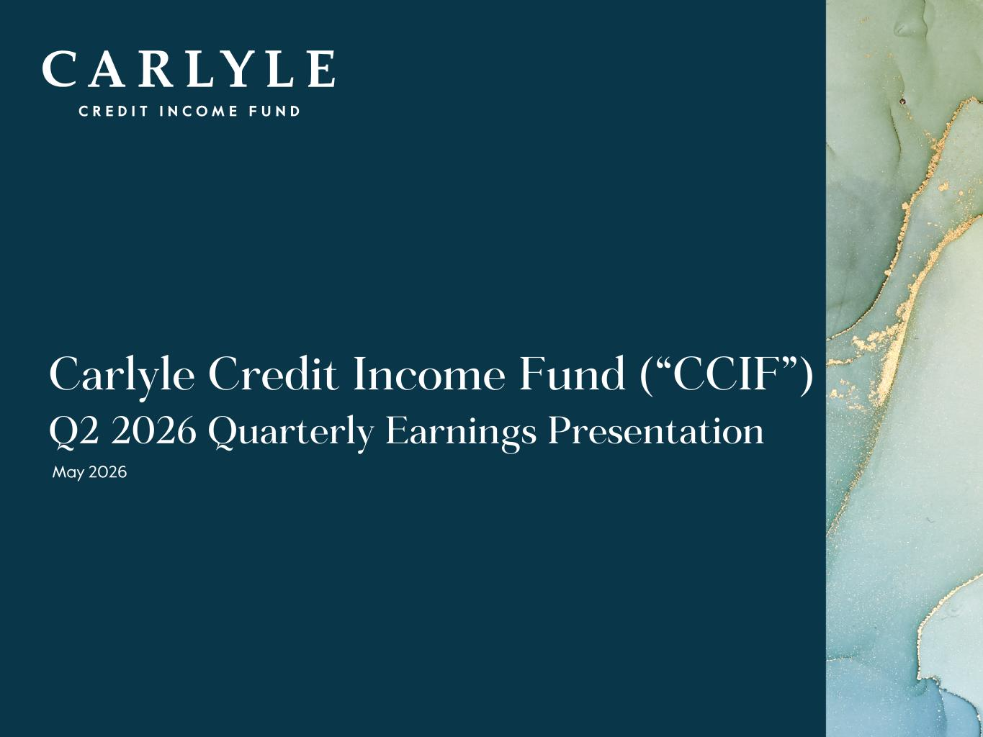
Joseph Castilla
+1-866-277-8243
investorrelations@carlylecreditincomefund.com

Investors:
Media:
R-171, G-132, B-51 R-108, G-132, B-156 R-97, G-161, B-224 R-10, G-54, B-74 R-29, G-101, B-113 R-182, G-231, B-250 R-215, G-185, B-122 R-196, G-206, B-215 R-171, G-202, B-243 R-13, G-107, B-147 R-33, G-152, B-172 R-208, G-232, B-248 R-0, G-0, B-0 R-95, G-95, B-95 R-188, G-188, B-188 R-235, G-235, B-235 R-242, G-232, B-211 R-196, G-234, B-240 1 Carlyle Credit Income Fund (“CCIF”) Q2 2026 Quarterly Earnings Presentation May 2026

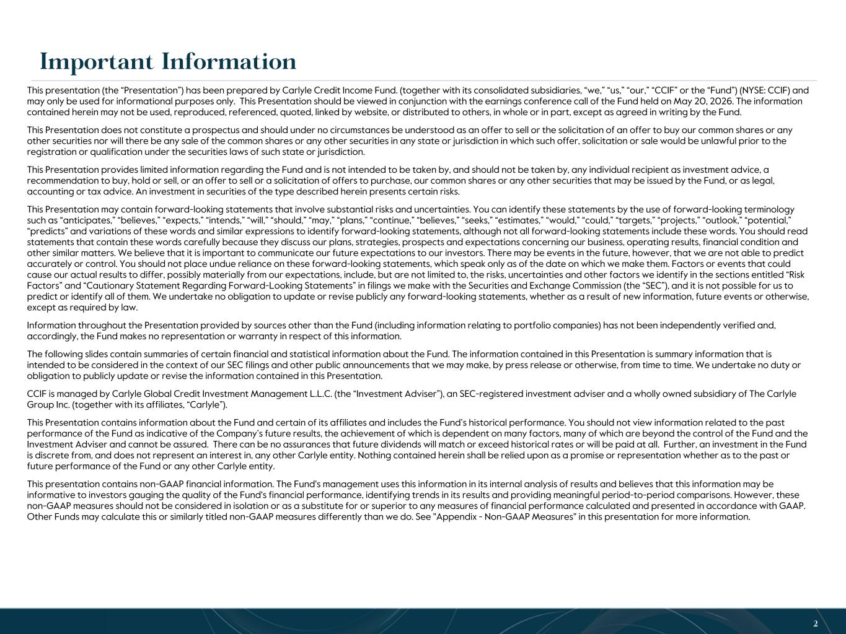
R-171, G-132, B-51 R-108, G-132, B-156 R-97, G-161, B-224 R-10, G-54, B-74 R-29, G-101, B-113 R-182, G-231, B-250 R-215, G-185, B-122 R-196, G-206, B-215 R-171, G-202, B-243 R-13, G-107, B-147 R-33, G-152, B-172 R-208, G-232, B-248 R-0, G-0, B-0 R-95, G-95, B-95 R-188, G-188, B-188 R-235, G-235, B-235 R-242, G-232, B-211 R-196, G-234, B-240 T R A D E S E C R E T & S T R I C T L Y C O N F I D E N T I A L 2 This presentation (the “Presentation”) has been prepared by Carlyle Credit Income Fund. (together with its consolidated subsidiaries, “we,” “us,” “our,” “CCIF” or the “Fund”) (NYSE: CCIF) and may only be used for informational purposes only. This Presentation should be viewed in conjunction with the earnings conference call of the Fund held on May 20, 2026. The information contained herein may not be used, reproduced, referenced, quoted, linked by website, or distributed to others, in whole or in part, except as agreed in writing by the Fund. This Presentation does not constitute a prospectus and should under no circumstances be understood as an offer to sell or the solicitation of an offer to buy our common shares or any other securities nor will there be any sale of the common shares or any other securities in any state or jurisdiction in which such offer, solicitation or sale would be unlawful prior to the registration or qualification under the securities laws of such state or jurisdiction. This Presentation provides limited information regarding the Fund and is not intended to be taken by, and should not be taken by, any individual recipient as investment advice, a recommendation to buy, hold or sell, or an offer to sell or a solicitation of offers to purchase, our common shares or any other securities that may be issued by the Fund, or as legal, accounting or tax advice. An investment in securities of the type described herein presents certain risks. This Presentation may contain forward-looking statements that involve substantial risks and uncertainties. You can identify these statements by the use of forward-looking terminology such as “anticipates,” “believes,” “expects,” “intends,” “will,” “should,” “may,” “plans,” “continue,” “believes,” “seeks,” “estimates,” “would,” “could,” “targets,” “projects,” “outlook,” “potential,” “predicts” and variations of these words and similar expressions to identify forward-looking statements, although not all forward-looking statements include these words. You should read statements that contain these words carefully because they discuss our plans, strategies, prospects and expectations concerning our business, operating results, financial condition and other similar matters. We believe that it is important to communicate our future expectations to our investors. There may be events in the future, however, that we are not able to predict accurately or control. You should not place undue reliance on these forward-looking statements, which speak only as of the date on which we make them. Factors or events that could cause our actual results to differ, possibly materially from our expectations, include, but are not limited to, the risks, uncertainties and other factors we identify in the sections entitled “Risk Factors” and “Cautionary Statement Regarding Forward-Looking Statements” in filings we make with the Securities and Exchange Commission (the “SEC”), and it is not possible for us to predict or identify all of them. We undertake no obligation to update or revise publicly any forward-looking statements, whether as a result of new information, future events or otherwise, except as required by law. Information throughout the Presentation provided by sources other than the Fund (including information relating to portfolio companies) has not been independently verified and, accordingly, the Fund makes no representation or warranty in respect of this information. The following slides contain summaries of certain financial and statistical information about the Fund. The information contained in this Presentation is summary information that is intended to be considered in the context of our SEC filings and other public announcements that we may make, by press release or otherwise, from time to time. We undertake no duty or obligation to publicly update or revise the information contained in this Presentation. CCIF is managed by Carlyle Global Credit Investment Management L.L.C. (the “Investment Adviser”), an SEC-registered investment adviser and a wholly owned subsidiary of The Carlyle Group Inc. (together with its affiliates, “Carlyle”). This Presentation contains information about the Fund and certain of its affiliates and includes the Fund’s historical performance. You should not view information related to the past performance of the Fund as indicative of the Company’s future results, the achievement of which is dependent on many factors, many of which are beyond the control of the Fund and the Investment Adviser and cannot be assured. There can be no assurances that future dividends will match or exceed historical rates or will be paid at all. Further, an investment in the Fund is discrete from, and does not represent an interest in, any other Carlyle entity. Nothing contained herein shall be relied upon as a promise or representation whether as to the past or future performance of the Fund or any other Carlyle entity. This presentation contains non-GAAP financial information. The Fund's management uses this information in its internal analysis of results and believes that this information may be informative to investors gauging the quality of the Fund's financial performance, identifying trends in its results and providing meaningful period-to-period comparisons. However, these non-GAAP measures should not be considered in isolation or as a substitute for or superior to any measures of financial performance calculated and presented in accordance with GAAP. Other Funds may calculate this or similarly titled non-GAAP measures differently than we do. See "Appendix - Non-GAAP Measures" in this presentation for more information. 2 Important Information

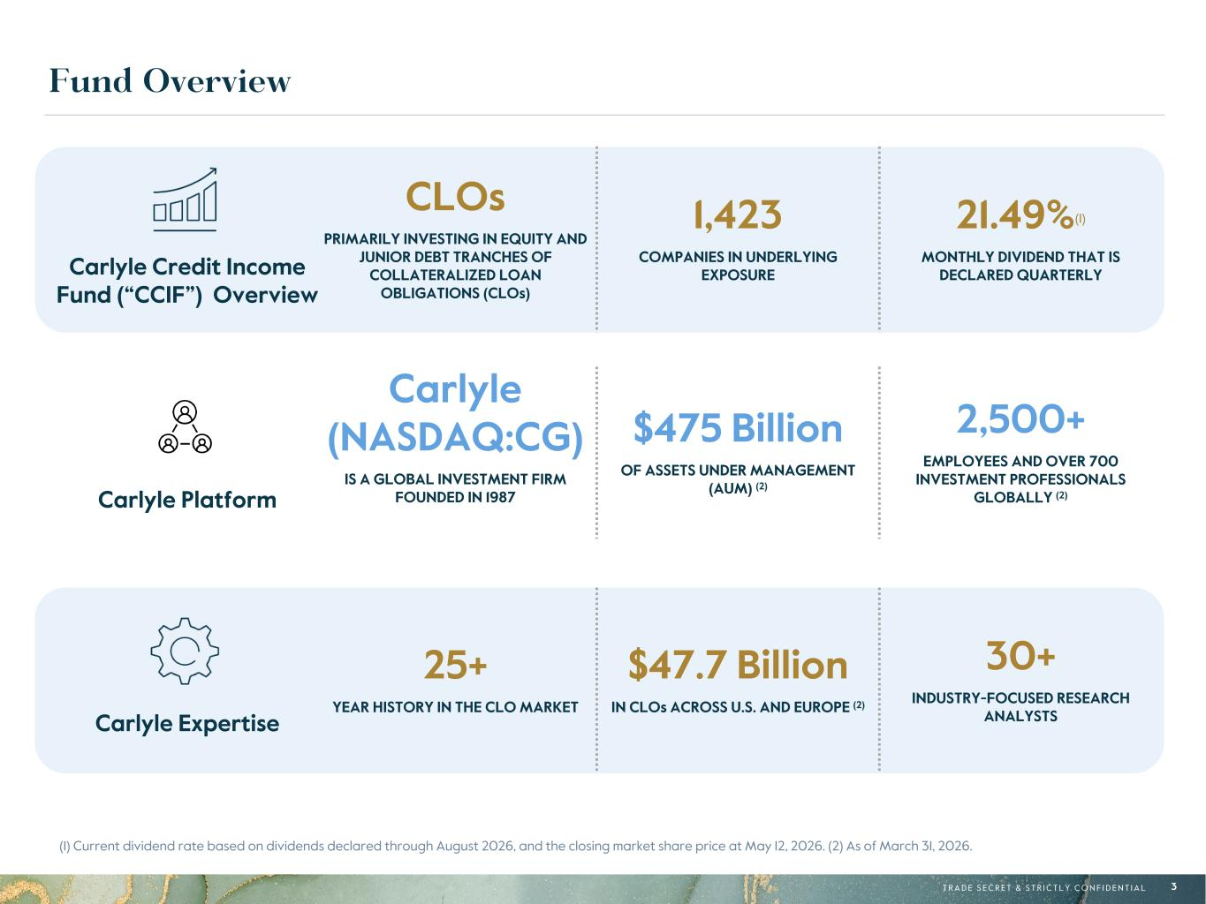
R-171, G-132, B-51 R-108, G-132, B-156 R-97, G-161, B-224 R-10, G-54, B-74 R-29, G-101, B-113 R-182, G-231, B-250 R-215, G-185, B-122 R-196, G-206, B-215 R-171, G-202, B-243 R-13, G-107, B-147 R-33, G-152, B-172 R-208, G-232, B-248 R-0, G-0, B-0 R-95, G-95, B-95 R-188, G-188, B-188 R-235, G-235, B-235 R-242, G-232, B-211 R-196, G-234, B-240 T R A D E S E C R E T & S T R I C T L Y C O N F I D E N T I A L 3 Fund Overview (1) Current dividend rate based on dividends declared through August 2026, and the closing market share price at May 12, 2026. (2) As of March 31, 2026. Carlyle Platform Carlyle Expertise CLOs PRIMARILY INVESTING IN EQUITY AND JUNIOR DEBT TRANCHES OF COLLATERALIZED LOAN OBLIGATIONS (CLOs) 1,423 COMPANIES IN UNDERLYING EXPOSURE 21.49%(1) MONTHLY DIVIDEND THAT IS DECLARED QUARTERLY Carlyle Credit Income Fund (“CCIF”) Overview Carlyle Platform Carlyle (NASDAQ:CG) IS A GLOBAL INVESTMENT FIRM FOUNDED IN 1987 $475 Billion OF ASSETS UNDER MANAGEMENT (AUM) (2) 2,500+ EMPLOYEES AND OVER 700 INVESTMENT PROFESSIONALS GLOBALLY (2) 25+ YEAR HISTORY IN THE CLO MARKET $47.7 Billion IN CLOs ACROSS U.S. AND EUROPE (2) 30+ INDUSTRY-FOCUSED RESEARCH ANALYSTS Carlyle Expertise

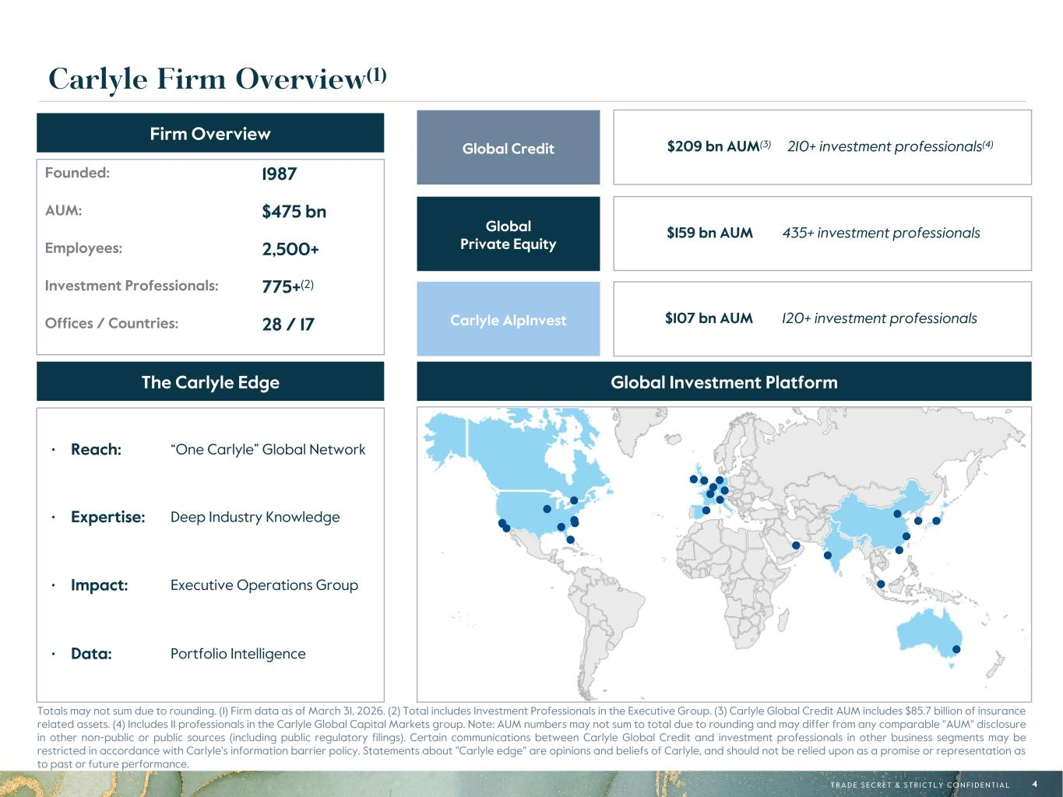
R-171, G-132, B-51 R-108, G-132, B-156 R-97, G-161, B-224 R-10, G-54, B-74 R-29, G-101, B-113 R-182, G-231, B-250 R-215, G-185, B-122 R-196, G-206, B-215 R-171, G-202, B-243 R-13, G-107, B-147 R-33, G-152, B-172 R-208, G-232, B-248 R-0, G-0, B-0 R-95, G-95, B-95 R-188, G-188, B-188 R-235, G-235, B-235 R-242, G-232, B-211 R-196, G-234, B-240 T R A D E S E C R E T & S T R I C T L Y C O N F I D E N T I A L 4 Totals may not sum due to rounding. (1) Firm data as of March 31, 2026. (2) Total includes Investment Professionals in the Executive Group. (3) Carlyle Global Credit AUM includes $85.7 billion of insurance related assets. (4) Includes 11 professionals in the Carlyle Global Capital Markets group. Note: AUM numbers may not sum to total due to rounding and may differ from any comparable "AUM" disclosure in other non-public or public sources (including public regulatory filings). Certain communications between Carlyle Global Credit and investment professionals in other business segments may be restricted in accordance with Carlyle's information barrier policy. Statements about "Carlyle edge" are opinions and beliefs of Carlyle, and should not be relied upon as a promise or representation as to past or future performance. Firm Overview The Carlyle Edge • Reach: “One Carlyle” Global Network • Expertise: Deep Industry Knowledge • Impact: Executive Operations Group • Data: Portfolio Intelligence Global Private Equity Global Credit Carlyle AlpInvest Global Investment Platform Founded: 1987 AUM: $475 bn Employees: 2,500+ Investment Professionals: 775+(2) Offices / Countries: 28 / 17 $159 bn AUM 435+ investment professionals $209 bn AUM(3) 210+ investment professionals(4) $107 bn AUM 120+ investment professionals Carlyle Firm Overview(1)

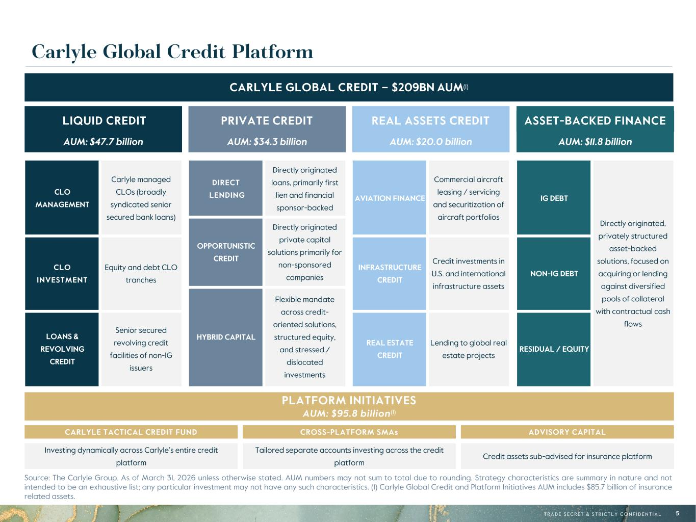
R-171, G-132, B-51 R-108, G-132, B-156 R-97, G-161, B-224 R-10, G-54, B-74 R-29, G-101, B-113 R-182, G-231, B-250 R-215, G-185, B-122 R-196, G-206, B-215 R-171, G-202, B-243 R-13, G-107, B-147 R-33, G-152, B-172 R-208, G-232, B-248 R-0, G-0, B-0 R-95, G-95, B-95 R-188, G-188, B-188 R-235, G-235, B-235 R-242, G-232, B-211 R-196, G-234, B-240 T R A D E S E C R E T & S T R I C T L Y C O N F I D E N T I A L 5 AUM: $11.8 billion ASSET-BACKED FINANCE Carlyle Global Credit Platform Source: The Carlyle Group. As of March 31, 2026 unless otherwise stated. AUM numbers may not sum to total due to rounding. Strategy characteristics are summary in nature and not intended to be an exhaustive list; any particular investment may not have any such characteristics. (1) Carlyle Global Credit and Platform Initiatives AUM includes $85.7 billion of insurance related assets. CARLYLE GLOBAL CREDIT – $209BN AUM(1) AUM: $47.7 billion LIQUID CREDIT AUM: $34.3 billion PRIVATE CREDIT AUM: $20.0 billion REAL ASSETS CREDIT CLO MANAGEMENT Carlyle managed CLOs (broadly syndicated senior secured bank loans) CLO INVESTMENT Equity and debt CLO tranches LOANS & REVOLVING CREDIT Senior secured revolving credit facilities of non-IG issuers DIRECT LENDING Directly originated loans, primarily first lien and financial sponsor-backed OPPORTUNISTIC CREDIT Directly originated private capital solutions primarily for non-sponsored companies HYBRID CAPITAL Flexible mandate across credit- oriented solutions, structured equity, and stressed / dislocated investments AVIATION FINANCE Commercial aircraft leasing / servicing and securitization of aircraft portfolios INFRASTRUCTURE CREDIT Credit investments in U.S. and international infrastructure assets REAL ESTATE CREDIT Lending to global real estate projects PLATFORM INITIATIVES AUM: $95.8 billion(1) CARLYLE TACTICAL CREDIT FUND CROSS-PLATFORM SMAs ADVISORY CAPITAL Investing dynamically across Carlyle’s entire credit platform Tailored separate accounts investing across the credit platform Credit assets sub-advised for insurance platform IG DEBT Directly originated, privately structured asset-backed solutions, focused on acquiring or lending against diversified pools of collateral with contractual cash flows NON-IG DEBT RESIDUAL / EQUITY

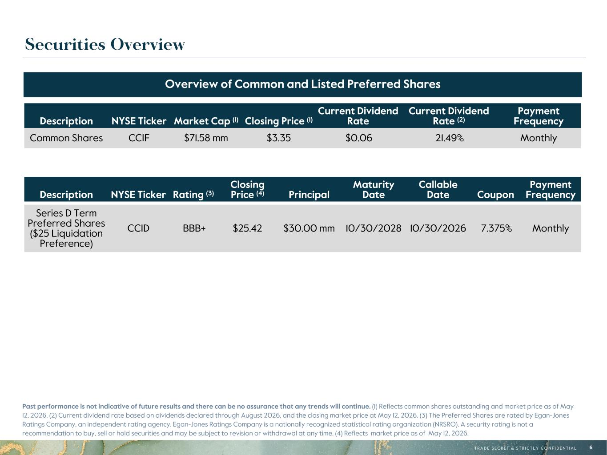
R-171, G-132, B-51 R-108, G-132, B-156 R-97, G-161, B-224 R-10, G-54, B-74 R-29, G-101, B-113 R-182, G-231, B-250 R-215, G-185, B-122 R-196, G-206, B-215 R-171, G-202, B-243 R-13, G-107, B-147 R-33, G-152, B-172 R-208, G-232, B-248 R-0, G-0, B-0 R-95, G-95, B-95 R-188, G-188, B-188 R-235, G-235, B-235 R-242, G-232, B-211 R-196, G-234, B-240 T R A D E S E C R E T & S T R I C T L Y C O N F I D E N T I A L 6 Securities Overview Description NYSE Ticker Market Cap (1) Closing Price (1) Current Dividend Rate Current Dividend Rate (2) Payment Frequency Common Shares CCIF $71.58 mm $3.35 $0.06 21.49% Monthly Overview of Common and Listed Preferred Shares Description NYSE Ticker Rating (3) Closing Price (4) Principal Maturity Date Callable Date Coupon Payment Frequency Series D Term Preferred Shares ($25 Liquidation Preference) CCID BBB+ $25.42 $30.00 mm 10/30/2028 10/30/2026 7.375% Monthly Past performance is not indicative of future results and there can be no assurance that any trends will continue. (1) Reflects common shares outstanding and market price as of May 12, 2026. (2) Current dividend rate based on dividends declared through August 2026, and the closing market price at May 12, 2026. (3) The Preferred Shares are rated by Egan-Jones Ratings Company, an independent rating agency. Egan-Jones Ratings Company is a nationally recognized statistical rating organization (NRSRO). A security rating is not a recommendation to buy, sell or hold securities and may be subject to revision or withdrawal at any time. (4) Reflects market price as of May 12, 2026.

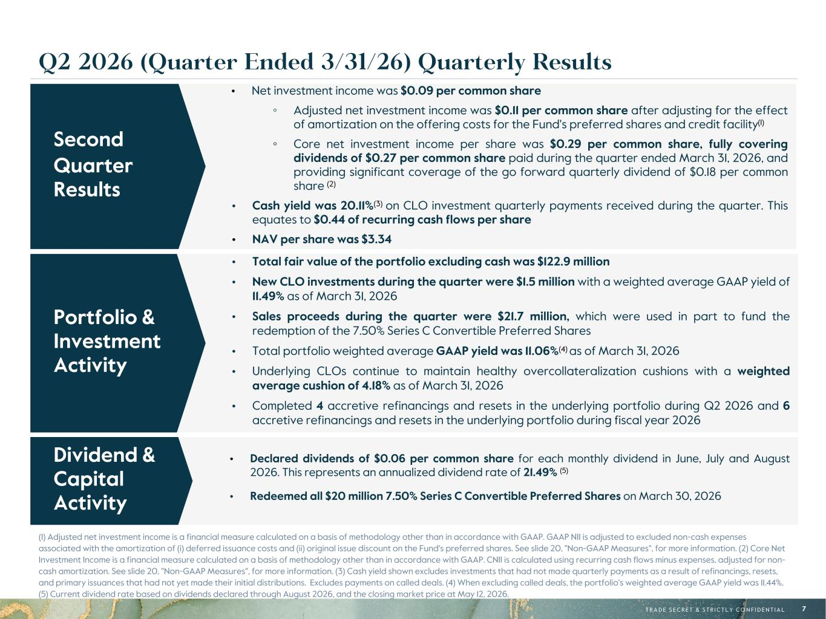
R-171, G-132, B-51 R-108, G-132, B-156 R-97, G-161, B-224 R-10, G-54, B-74 R-29, G-101, B-113 R-182, G-231, B-250 R-215, G-185, B-122 R-196, G-206, B-215 R-171, G-202, B-243 R-13, G-107, B-147 R-33, G-152, B-172 R-208, G-232, B-248 R-0, G-0, B-0 R-95, G-95, B-95 R-188, G-188, B-188 R-235, G-235, B-235 R-242, G-232, B-211 R-196, G-234, B-240 T R A D E S E C R E T & S T R I C T L Y C O N F I D E N T I A L 7 • Declared dividends of $0.06 per common share for each monthly dividend in June, July and August 2026. This represents an annualized dividend rate of 21.49% (5) • Redeemed all $20 million 7.50% Series C Convertible Preferred Shares on March 30, 2026 • Net investment income was $0.09 per common share ◦ Adjusted net investment income was $0.11 per common share after adjusting for the effect of amortization on the offering costs for the Fund's preferred shares and credit facility(1) ◦ Core net investment income per share was $0.29 per common share, fully covering dividends of $0.27 per common share paid during the quarter ended March 31, 2026, and providing significant coverage of the go forward quarterly dividend of $0.18 per common share (2) • Cash yield was 20.11%(3) on CLO investment quarterly payments received during the quarter. This equates to $0.44 of recurring cash flows per share • NAV per share was $3.34 (1) Adjusted net investment income is a financial measure calculated on a basis of methodology other than in accordance with GAAP. GAAP NII is adjusted to excluded non-cash expenses associated with the amortization of (i) deferred issuance costs and (ii) original issue discount on the Fund's preferred shares. See slide 20, "Non-GAAP Measures", for more information. (2) Core Net Investment Income is a financial measure calculated on a basis of methodology other than in accordance with GAAP. CNII is calculated using recurring cash flows minus expenses, adjusted for non- cash amortization. See slide 20, "Non-GAAP Measures", for more information. (3) Cash yield shown excludes investments that had not made quarterly payments as a result of refinancings, resets, and primary issuances that had not yet made their initial distributions. Excludes payments on called deals. (4) When excluding called deals, the portfolio's weighted average GAAP yield was 11.44%. (5) Current dividend rate based on dividends declared through August 2026, and the closing market price at May 12, 2026. Dividend & Capital Activity Second Quarter Results Q2 2026 (Quarter Ended 3/31/26) Quarterly Results • Total fair value of the portfolio excluding cash was $122.9 million • New CLO investments during the quarter were $1.5 million with a weighted average GAAP yield of 11.49% as of March 31, 2026 • Sales proceeds during the quarter were $21.7 million, which were used in part to fund the redemption of the 7.50% Series C Convertible Preferred Shares • Total portfolio weighted average GAAP yield was 11.06%(4) as of March 31, 2026 • Underlying CLOs continue to maintain healthy overcollateralization cushions with a weighted average cushion of 4.18% as of March 31, 2026 • Completed 4 accretive refinancings and resets in the underlying portfolio during Q2 2026 and 6 accretive refinancings and resets in the underlying portfolio during fiscal year 2026 Portfolio & Investment Activity

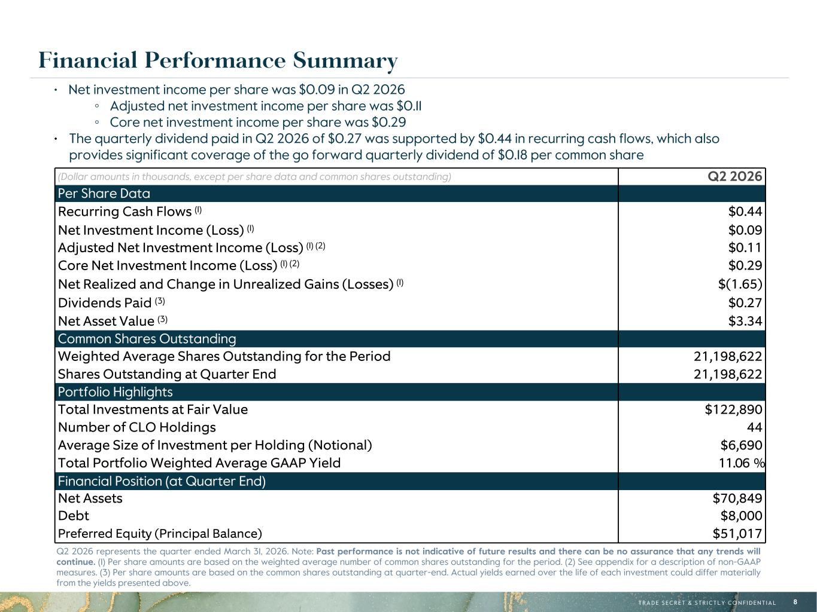
R-171, G-132, B-51 R-108, G-132, B-156 R-97, G-161, B-224 R-10, G-54, B-74 R-29, G-101, B-113 R-182, G-231, B-250 R-215, G-185, B-122 R-196, G-206, B-215 R-171, G-202, B-243 R-13, G-107, B-147 R-33, G-152, B-172 R-208, G-232, B-248 R-0, G-0, B-0 R-95, G-95, B-95 R-188, G-188, B-188 R-235, G-235, B-235 R-242, G-232, B-211 R-196, G-234, B-240 T R A D E S E C R E T & S T R I C T L Y C O N F I D E N T I A L 8 • Net investment income per share was $0.09 in Q2 2026 ◦ Adjusted net investment income per share was $0.11 ◦ Core net investment income per share was $0.29 • The quarterly dividend paid in Q2 2026 of $0.27 was supported by $0.44 in recurring cash flows, which also provides significant coverage of the go forward quarterly dividend of $0.18 per common share Q2 2026 represents the quarter ended March 31, 2026. Note: Past performance is not indicative of future results and there can be no assurance that any trends will continue. (1) Per share amounts are based on the weighted average number of common shares outstanding for the period. (2) See appendix for a description of non-GAAP measures. (3) Per share amounts are based on the common shares outstanding at quarter-end. Actual yields earned over the life of each investment could differ materially from the yields presented above. Financial Performance Summary (Dollar amounts in thousands, except per share data and common shares outstanding) Q2 2026 Per Share Data Recurring Cash Flows (1) $0.44 Net Investment Income (Loss) (1) $0.09 Adjusted Net Investment Income (Loss) (1) (2) $0.11 Core Net Investment Income (Loss) (1) (2) $0.29 Net Realized and Change in Unrealized Gains (Losses) (1) $(1.65) Dividends Paid (3) $0.27 Net Asset Value (3) $3.34 Common Shares Outstanding Weighted Average Shares Outstanding for the Period 21,198,622 Shares Outstanding at Quarter End 21,198,622 Portfolio Highlights Total Investments at Fair Value $122,890 Number of CLO Holdings 44 Average Size of Investment per Holding (Notional) $6,690 Total Portfolio Weighted Average GAAP Yield 11.06 % Financial Position (at Quarter End) Net Assets $70,849 Debt $8,000 Preferred Equity (Principal Balance) $51,017

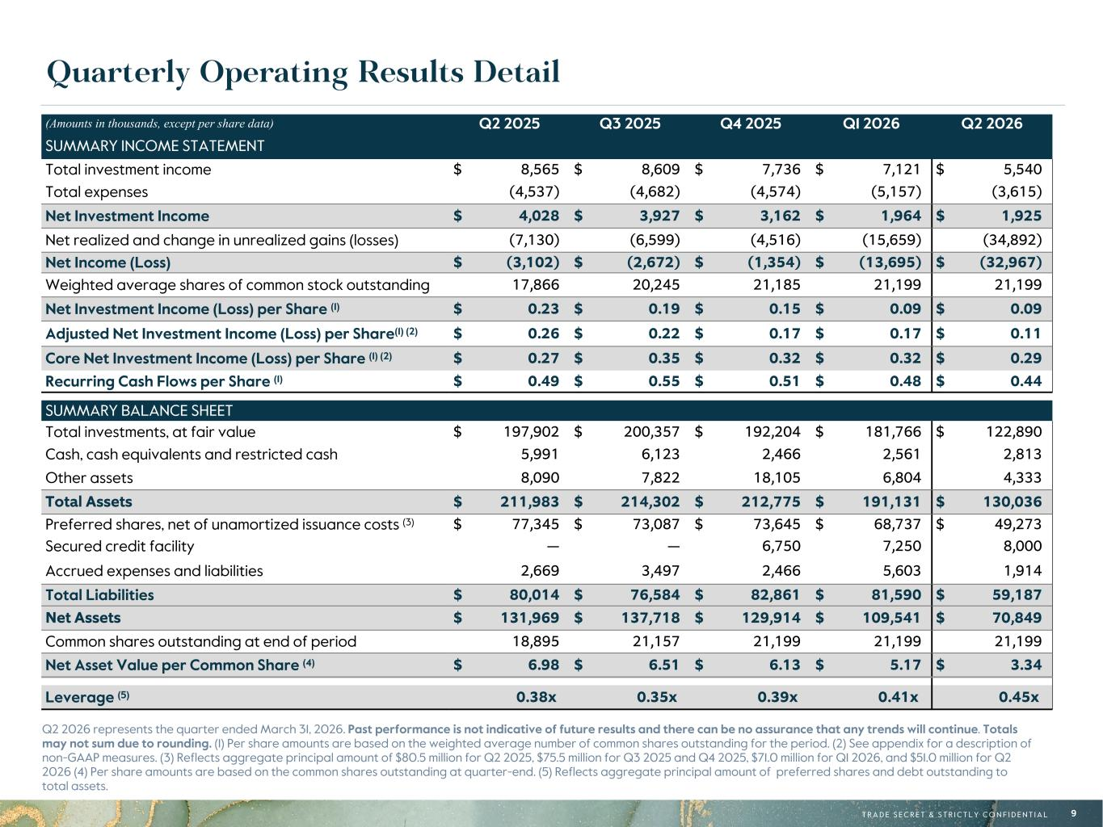
R-171, G-132, B-51 R-108, G-132, B-156 R-97, G-161, B-224 R-10, G-54, B-74 R-29, G-101, B-113 R-182, G-231, B-250 R-215, G-185, B-122 R-196, G-206, B-215 R-171, G-202, B-243 R-13, G-107, B-147 R-33, G-152, B-172 R-208, G-232, B-248 R-0, G-0, B-0 R-95, G-95, B-95 R-188, G-188, B-188 R-235, G-235, B-235 R-242, G-232, B-211 R-196, G-234, B-240 T R A D E S E C R E T & S T R I C T L Y C O N F I D E N T I A L 9 Quarterly Operating Results Detail Q2 2026 represents the quarter ended March 31, 2026. Past performance is not indicative of future results and there can be no assurance that any trends will continue. Totals may not sum due to rounding. (1) Per share amounts are based on the weighted average number of common shares outstanding for the period. (2) See appendix for a description of non-GAAP measures. (3) Reflects aggregate principal amount of $80.5 million for Q2 2025, $75.5 million for Q3 2025 and Q4 2025, $71.0 million for Q1 2026, and $51.0 million for Q2 2026 (4) Per share amounts are based on the common shares outstanding at quarter-end. (5) Reflects aggregate principal amount of preferred shares and debt outstanding to total assets. (Amounts in thousands, except per share data) Q2 2025 Q3 2025 Q4 2025 Q1 2026 Q2 2026 SUMMARY INCOME STATEMENT Total investment income $ 8,565 $ 8,609 $ 7,736 $ 7,121 $ 5,540 Total expenses (4,537) (4,682) (4,574) (5,157) (3,615) Net Investment Income $ 4,028 $ 3,927 $ 3,162 $ 1,964 $ 1,925 Net realized and change in unrealized gains (losses) (7,130) (6,599) (4,516) (15,659) (34,892) Net Income (Loss) $ (3,102) $ (2,672) $ (1,354) $ (13,695) $ (32,967) Weighted average shares of common stock outstanding 17,866 20,245 21,185 21,199 21,199 Net Investment Income (Loss) per Share (1) $ 0.23 $ 0.19 $ 0.15 $ 0.09 $ 0.09 Adjusted Net Investment Income (Loss) per Share(1) (2) $ 0.26 $ 0.22 $ 0.17 $ 0.17 $ 0.11 Core Net Investment Income (Loss) per Share (1) (2) $ 0.27 $ 0.35 $ 0.32 $ 0.32 $ 0.29 Recurring Cash Flows per Share (1) $ 0.49 $ 0.55 $ 0.51 $ 0.48 $ 0.44 SUMMARY BALANCE SHEET Total investments, at fair value $ 197,902 $ 200,357 $ 192,204 $ 181,766 $ 122,890 Cash, cash equivalents and restricted cash 5,991 6,123 2,466 2,561 2,813 Other assets 8,090 7,822 18,105 6,804 4,333 Total Assets $ 211,983 $ 214,302 $ 212,775 $ 191,131 $ 130,036 Preferred shares, net of unamortized issuance costs (3) $ 77,345 $ 73,087 $ 73,645 $ 68,737 $ 49,273 Secured credit facility — — 6,750 7,250 8,000 Accrued expenses and liabilities 2,669 3,497 2,466 5,603 1,914 Total Liabilities $ 80,014 $ 76,584 $ 82,861 $ 81,590 $ 59,187 Net Assets $ 131,969 $ 137,718 $ 129,914 $ 109,541 $ 70,849 Common shares outstanding at end of period 18,895 21,157 21,199 21,199 21,199 Net Asset Value per Common Share (4) $ 6.98 $ 6.51 $ 6.13 $ 5.17 $ 3.34 Leverage (5) 0.38x 0.35x 0.39x 0.41x 0.45x

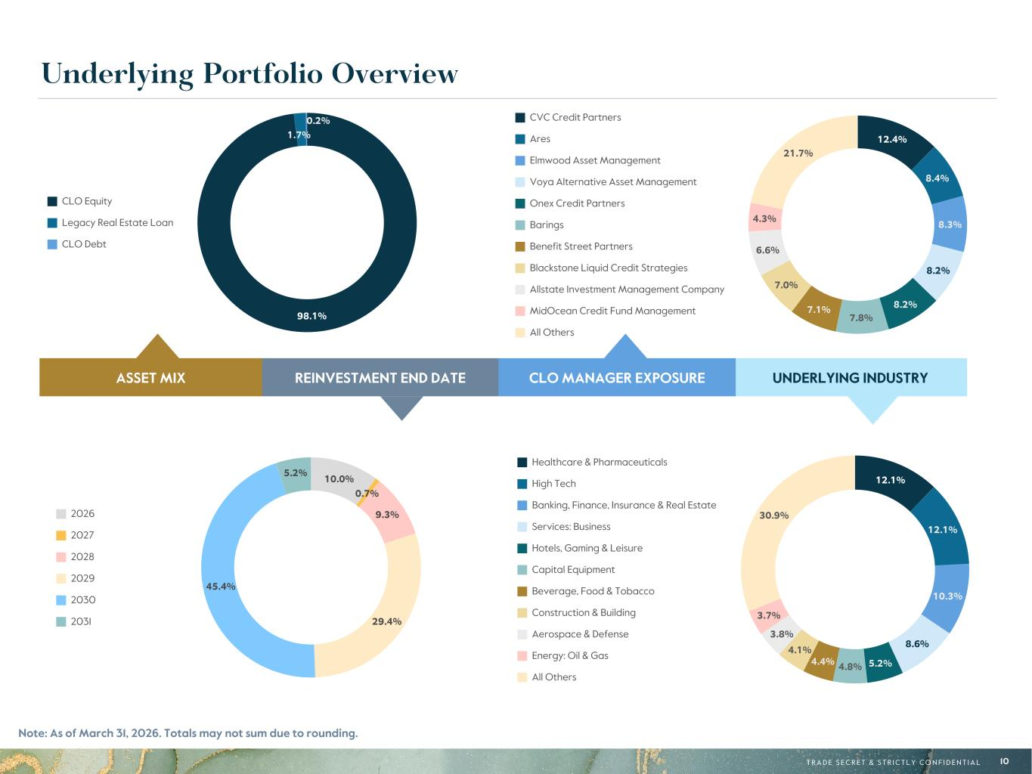
R-171, G-132, B-51 R-108, G-132, B-156 R-97, G-161, B-224 R-10, G-54, B-74 R-29, G-101, B-113 R-182, G-231, B-250 R-215, G-185, B-122 R-196, G-206, B-215 R-171, G-202, B-243 R-13, G-107, B-147 R-33, G-152, B-172 R-208, G-232, B-248 R-0, G-0, B-0 R-95, G-95, B-95 R-188, G-188, B-188 R-235, G-235, B-235 R-242, G-232, B-211 R-196, G-234, B-240 T R A D E S E C R E T & S T R I C T L Y C O N F I D E N T I A L 10 12.1% 12.1% 10.3% 8.6% 5.2%4.8%4.4% 4.1% 3.8% 3.7% 30.9% Healthcare & Pharmaceuticals High Tech Banking, Finance, Insurance & Real Estate Services: Business Hotels, Gaming & Leisure Capital Equipment Beverage, Food & Tobacco Construction & Building Aerospace & Defense Energy: Oil & Gas All Others UNDERLYING INDUSTRYCLO MANAGER EXPOSUREREINVESTMENT END DATEASSET MIX 10.0% 0.7% 9.3% 29.4% 45.4% 5.2% 2026 2027 2028 2029 2030 2031 Underlying Portfolio Overview Note: As of March 31, 2026. Totals may not sum due to rounding. 12.4% 8.4% 8.3% 8.2% 8.2% 7.8% 7.1% 7.0% 6.6% 4.3% 21.7% CVC Credit Partners Ares Elmwood Asset Management Voya Alternative Asset Management Onex Credit Partners Barings Benefit Street Partners Blackstone Liquid Credit Strategies Allstate Investment Management Company MidOcean Credit Fund Management All Others 98.1% 1.7% 0.2% CLO Equity Legacy Real Estate Loan CLO Debt

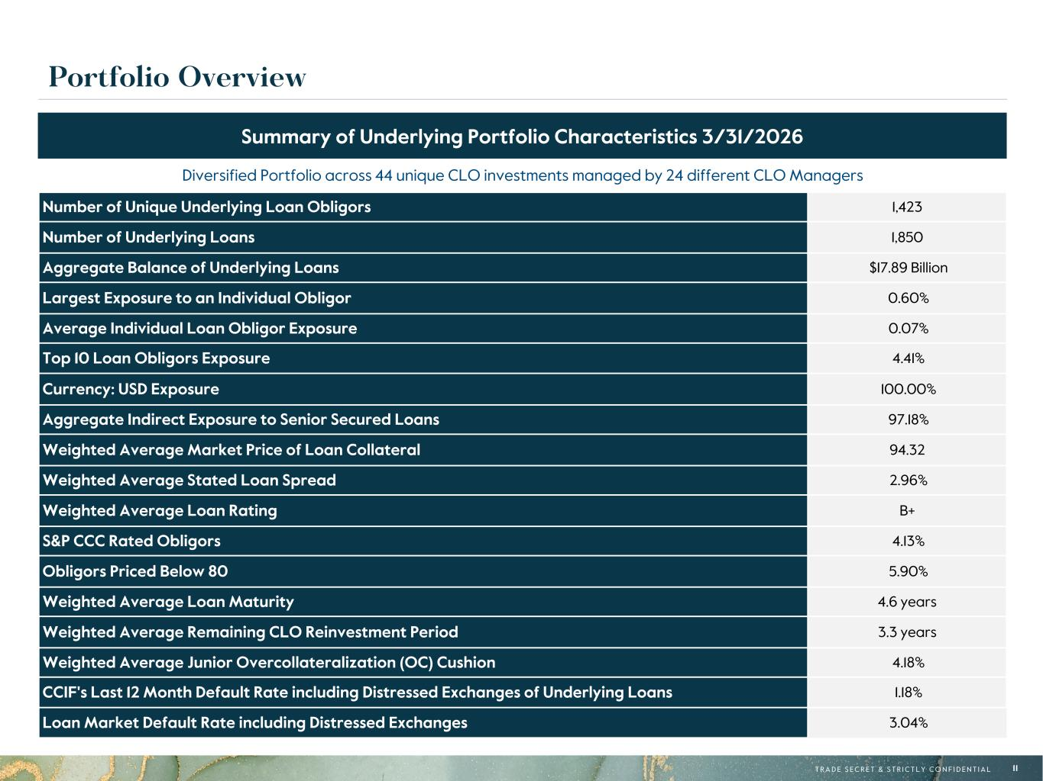
R-171, G-132, B-51 R-108, G-132, B-156 R-97, G-161, B-224 R-10, G-54, B-74 R-29, G-101, B-113 R-182, G-231, B-250 R-215, G-185, B-122 R-196, G-206, B-215 R-171, G-202, B-243 R-13, G-107, B-147 R-33, G-152, B-172 R-208, G-232, B-248 R-0, G-0, B-0 R-95, G-95, B-95 R-188, G-188, B-188 R-235, G-235, B-235 R-242, G-232, B-211 R-196, G-234, B-240 T R A D E S E C R E T & S T R I C T L Y C O N F I D E N T I A L 11 Portfolio Overview Diversified Portfolio across 44 unique CLO investments managed by 24 different CLO Managers Number of Unique Underlying Loan Obligors 1,423 Number of Underlying Loans 1,850 Aggregate Balance of Underlying Loans $17.89 Billion Largest Exposure to an Individual Obligor 0.60% Average Individual Loan Obligor Exposure 0.07% Top 10 Loan Obligors Exposure 4.41% Currency: USD Exposure 100.00% Aggregate Indirect Exposure to Senior Secured Loans 97.18% Weighted Average Market Price of Loan Collateral 94.32 Weighted Average Stated Loan Spread 2.96% Weighted Average Loan Rating B+ S&P CCC Rated Obligors 4.13% Obligors Priced Below 80 5.90% Weighted Average Loan Maturity 4.6 years Weighted Average Remaining CLO Reinvestment Period 3.3 years Weighted Average Junior Overcollateralization (OC) Cushion 4.18% CCIF's Last 12 Month Default Rate including Distressed Exchanges of Underlying Loans 1.18% Loan Market Default Rate including Distressed Exchanges 3.04% Summary of Underlying Portfolio Characteristics 3/31/2026

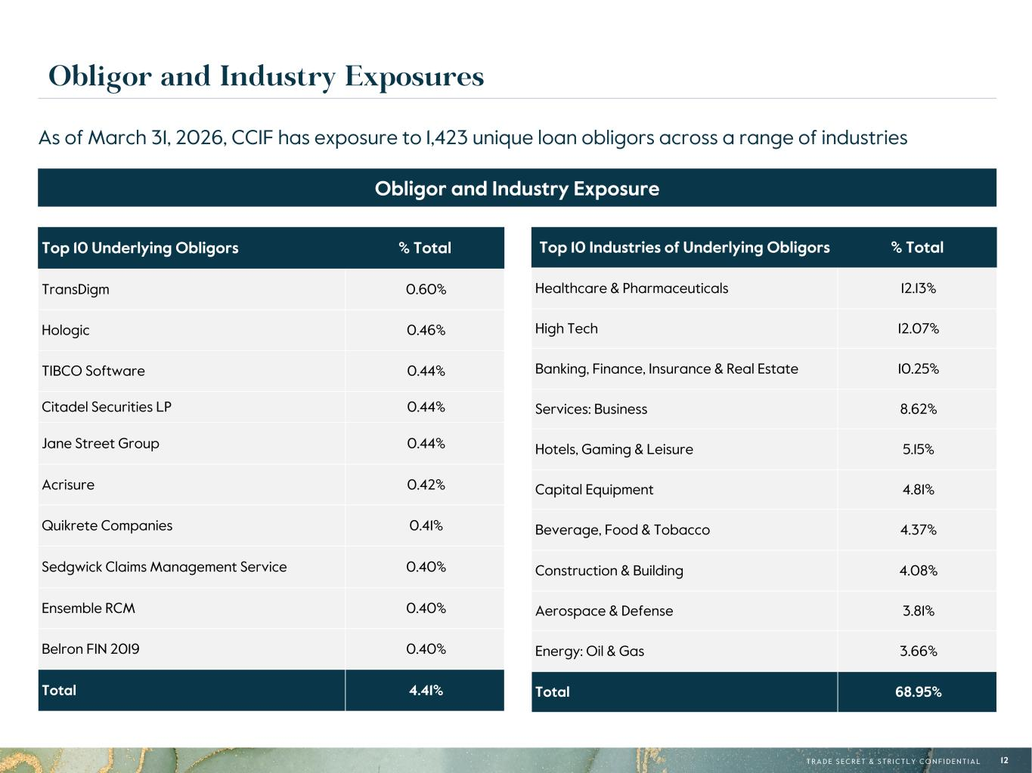
R-171, G-132, B-51 R-108, G-132, B-156 R-97, G-161, B-224 R-10, G-54, B-74 R-29, G-101, B-113 R-182, G-231, B-250 R-215, G-185, B-122 R-196, G-206, B-215 R-171, G-202, B-243 R-13, G-107, B-147 R-33, G-152, B-172 R-208, G-232, B-248 R-0, G-0, B-0 R-95, G-95, B-95 R-188, G-188, B-188 R-235, G-235, B-235 R-242, G-232, B-211 R-196, G-234, B-240 T R A D E S E C R E T & S T R I C T L Y C O N F I D E N T I A L 12 Obligor and Industry Exposures Top 10 Underlying Obligors % Total TransDigm 0.60% Hologic 0.46% TIBCO Software 0.44% Citadel Securities LP 0.44% Jane Street Group 0.44% Acrisure 0.42% Quikrete Companies 0.41% Sedgwick Claims Management Service 0.40% Ensemble RCM 0.40% Belron FIN 2019 0.40% Total 4.41% As of March 31, 2026, CCIF has exposure to 1,423 unique loan obligors across a range of industries Obligor and Industry Exposure Top 10 Industries of Underlying Obligors % Total Healthcare & Pharmaceuticals 12.13% High Tech 12.07% Banking, Finance, Insurance & Real Estate 10.25% Services: Business 8.62% Hotels, Gaming & Leisure 5.15% Capital Equipment 4.81% Beverage, Food & Tobacco 4.37% Construction & Building 4.08% Aerospace & Defense 3.81% Energy: Oil & Gas 3.66% Total 68.95%

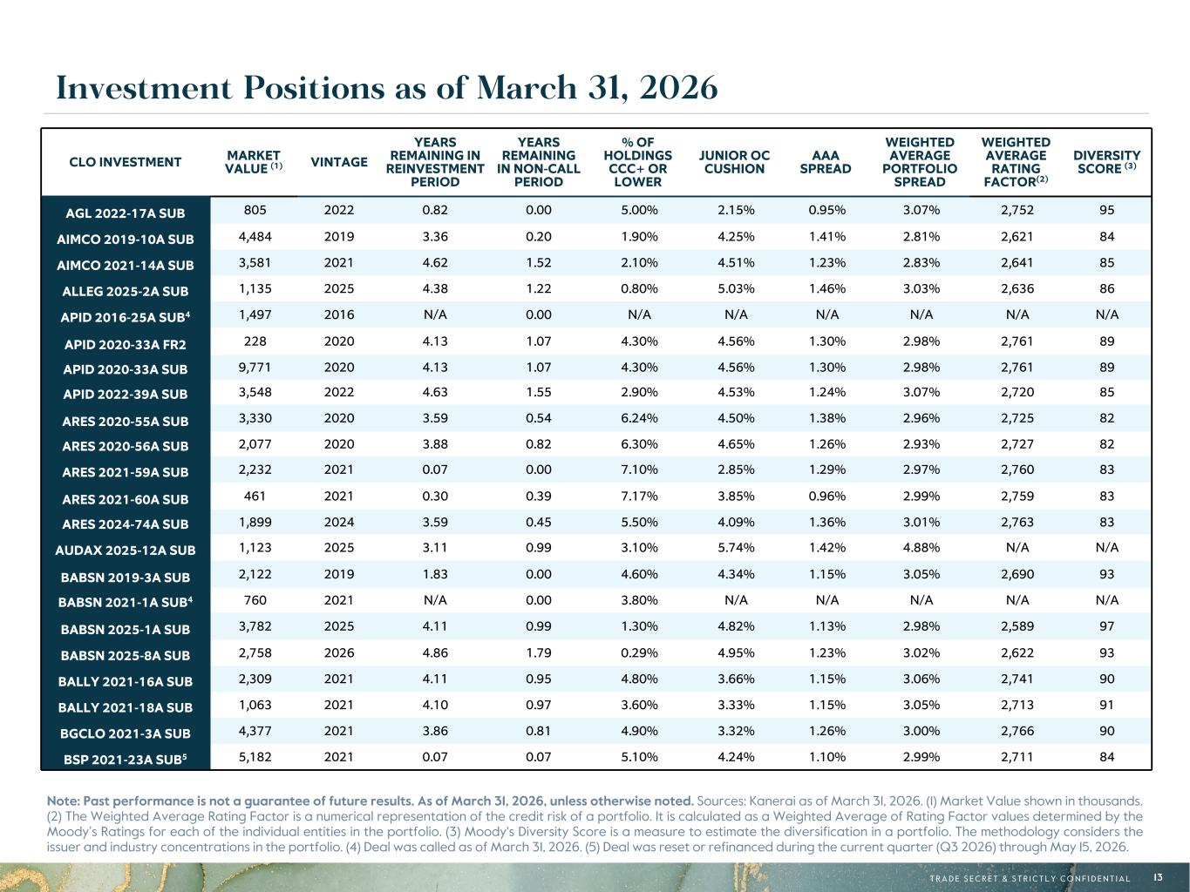
R-171, G-132, B-51 R-108, G-132, B-156 R-97, G-161, B-224 R-10, G-54, B-74 R-29, G-101, B-113 R-182, G-231, B-250 R-215, G-185, B-122 R-196, G-206, B-215 R-171, G-202, B-243 R-13, G-107, B-147 R-33, G-152, B-172 R-208, G-232, B-248 R-0, G-0, B-0 R-95, G-95, B-95 R-188, G-188, B-188 R-235, G-235, B-235 R-242, G-232, B-211 R-196, G-234, B-240 T R A D E S E C R E T & S T R I C T L Y C O N F I D E N T I A L 13 Investment Positions as of March 31, 2026 CLO INVESTMENT MARKET VALUE (1) VINTAGE YEARS REMAINING IN REINVESTMENT PERIOD YEARS REMAINING IN NON-CALL PERIOD % OF HOLDINGS CCC+ OR LOWER JUNIOR OC CUSHION AAA SPREAD WEIGHTED AVERAGE PORTFOLIO SPREAD WEIGHTED AVERAGE RATING FACTOR(2) DIVERSITY SCORE (3) AGL 2022-17A SUB 805 2022 0.82 0.00 5.00% 2.15% 0.95% 3.07% 2,752 95 AIMCO 2019-10A SUB 4,484 2019 3.36 0.20 1.90% 4.25% 1.41% 2.81% 2,621 84 AIMCO 2021-14A SUB 3,581 2021 4.62 1.52 2.10% 4.51% 1.23% 2.83% 2,641 85 ALLEG 2025-2A SUB 1,135 2025 4.38 1.22 0.80% 5.03% 1.46% 3.03% 2,636 86 APID 2016-25A SUB4 1,497 2016 N/A 0.00 N/A N/A N/A N/A N/A N/A APID 2020-33A FR2 228 2020 4.13 1.07 4.30% 4.56% 1.30% 2.98% 2,761 89 APID 2020-33A SUB 9,771 2020 4.13 1.07 4.30% 4.56% 1.30% 2.98% 2,761 89 APID 2022-39A SUB 3,548 2022 4.63 1.55 2.90% 4.53% 1.24% 3.07% 2,720 85 ARES 2020-55A SUB 3,330 2020 3.59 0.54 6.24% 4.50% 1.38% 2.96% 2,725 82 ARES 2020-56A SUB 2,077 2020 3.88 0.82 6.30% 4.65% 1.26% 2.93% 2,727 82 ARES 2021-59A SUB 2,232 2021 0.07 0.00 7.10% 2.85% 1.29% 2.97% 2,760 83 ARES 2021-60A SUB 461 2021 0.30 0.39 7.17% 3.85% 0.96% 2.99% 2,759 83 ARES 2024-74A SUB 1,899 2024 3.59 0.45 5.50% 4.09% 1.36% 3.01% 2,763 83 AUDAX 2025-12A SUB 1,123 2025 3.11 0.99 3.10% 5.74% 1.42% 4.88% N/A N/A BABSN 2019-3A SUB 2,122 2019 1.83 0.00 4.60% 4.34% 1.15% 3.05% 2,690 93 BABSN 2021-1A SUB4 760 2021 N/A 0.00 3.80% N/A N/A N/A N/A N/A BABSN 2025-1A SUB 3,782 2025 4.11 0.99 1.30% 4.82% 1.13% 2.98% 2,589 97 BABSN 2025-8A SUB 2,758 2026 4.86 1.79 0.29% 4.95% 1.23% 3.02% 2,622 93 BALLY 2021-16A SUB 2,309 2021 4.11 0.95 4.80% 3.66% 1.15% 3.06% 2,741 90 BALLY 2021-18A SUB 1,063 2021 4.10 0.97 3.60% 3.33% 1.15% 3.05% 2,713 91 BGCLO 2021-3A SUB 4,377 2021 3.86 0.81 4.90% 3.32% 1.26% 3.00% 2,766 90 BSP 2021-23A SUB5 5,182 2021 0.07 0.07 5.10% 4.24% 1.10% 2.99% 2,711 84 Note: Past performance is not a guarantee of future results. As of March 31, 2026, unless otherwise noted. Sources: Kanerai as of March 31, 2026. (1) Market Value shown in thousands. (2) The Weighted Average Rating Factor is a numerical representation of the credit risk of a portfolio. It is calculated as a Weighted Average of Rating Factor values determined by the Moody’s Ratings for each of the individual entities in the portfolio. (3) Moody's Diversity Score is a measure to estimate the diversification in a portfolio. The methodology considers the issuer and industry concentrations in the portfolio. (4) Deal was called as of March 31, 2026. (5) Deal was reset or refinanced during the current quarter (Q3 2026) through May 15, 2026.

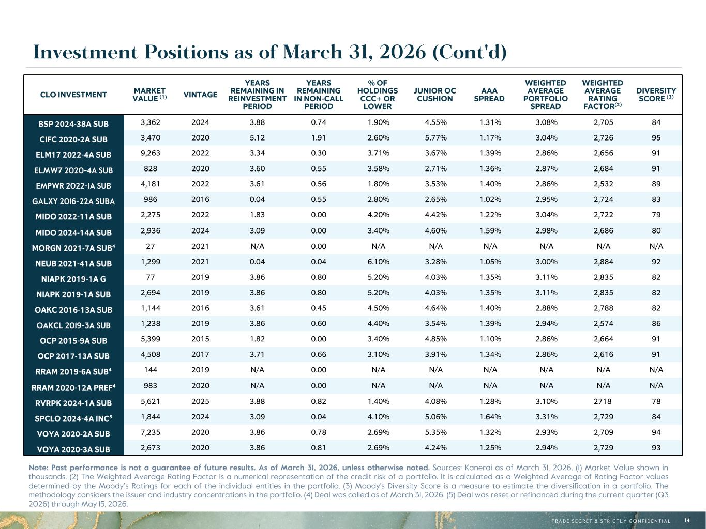
R-171, G-132, B-51 R-108, G-132, B-156 R-97, G-161, B-224 R-10, G-54, B-74 R-29, G-101, B-113 R-182, G-231, B-250 R-215, G-185, B-122 R-196, G-206, B-215 R-171, G-202, B-243 R-13, G-107, B-147 R-33, G-152, B-172 R-208, G-232, B-248 R-0, G-0, B-0 R-95, G-95, B-95 R-188, G-188, B-188 R-235, G-235, B-235 R-242, G-232, B-211 R-196, G-234, B-240 T R A D E S E C R E T & S T R I C T L Y C O N F I D E N T I A L 14 Investment Positions as of March 31, 2026 (Cont'd) CLO INVESTMENT MARKET VALUE (1) VINTAGE YEARS REMAINING IN REINVESTMENT PERIOD YEARS REMAINING IN NON-CALL PERIOD % OF HOLDINGS CCC+ OR LOWER JUNIOR OC CUSHION AAA SPREAD WEIGHTED AVERAGE PORTFOLIO SPREAD WEIGHTED AVERAGE RATING FACTOR(2) DIVERSITY SCORE (3) BSP 2024-38A SUB 3,362 2024 3.88 0.74 1.90% 4.55% 1.31% 3.08% 2,705 84 CIFC 2020-2A SUB 3,470 2020 5.12 1.91 2.60% 5.77% 1.17% 3.04% 2,726 95 ELM17 2022-4A SUB 9,263 2022 3.34 0.30 3.71% 3.67% 1.39% 2.86% 2,656 91 ELMW7 2020-4A SUB 828 2020 3.60 0.55 3.58% 2.71% 1.36% 2.87% 2,684 91 EMPWR 2022-1A SUB 4,181 2022 3.61 0.56 1.80% 3.53% 1.40% 2.86% 2,532 89 GALXY 2016-22A SUBA 986 2016 0.04 0.55 2.80% 2.65% 1.02% 2.95% 2,724 83 MIDO 2022-11A SUB 2,275 2022 1.83 0.00 4.20% 4.42% 1.22% 3.04% 2,722 79 MIDO 2024-14A SUB 2,936 2024 3.09 0.00 3.40% 4.60% 1.59% 2.98% 2,686 80 MORGN 2021-7A SUB4 27 2021 N/A 0.00 N/A N/A N/A N/A N/A N/A NEUB 2021-41A SUB 1,299 2021 0.04 0.04 6.10% 3.28% 1.05% 3.00% 2,884 92 NIAPK 2019-1A G 77 2019 3.86 0.80 5.20% 4.03% 1.35% 3.11% 2,835 82 NIAPK 2019-1A SUB 2,694 2019 3.86 0.80 5.20% 4.03% 1.35% 3.11% 2,835 82 OAKC 2016-13A SUB 1,144 2016 3.61 0.45 4.50% 4.64% 1.40% 2.88% 2,788 82 OAKCL 2019-3A SUB 1,238 2019 3.86 0.60 4.40% 3.54% 1.39% 2.94% 2,574 86 OCP 2015-9A SUB 5,399 2015 1.82 0.00 3.40% 4.85% 1.10% 2.86% 2,664 91 OCP 2017-13A SUB 4,508 2017 3.71 0.66 3.10% 3.91% 1.34% 2.86% 2,616 91 RRAM 2019-6A SUB4 144 2019 N/A 0.00 N/A N/A N/A N/A N/A N/A RRAM 2020-12A PREF4 983 2020 N/A 0.00 N/A N/A N/A N/A N/A N/A RVRPK 2024-1A SUB 5,621 2025 3.88 0.82 1.40% 4.08% 1.28% 3.10% 2718 78 SPCLO 2024-4A INC5 1,844 2024 3.09 0.04 4.10% 5.06% 1.64% 3.31% 2,729 84 VOYA 2020-2A SUB 7,235 2020 3.86 0.78 2.69% 5.35% 1.32% 2.93% 2,709 94 VOYA 2020-3A SUB 2,673 2020 3.86 0.81 2.69% 4.24% 1.25% 2.94% 2,729 93 Note: Past performance is not a guarantee of future results. As of March 31, 2026, unless otherwise noted. Sources: Kanerai as of March 31, 2026. (1) Market Value shown in thousands. (2) The Weighted Average Rating Factor is a numerical representation of the credit risk of a portfolio. It is calculated as a Weighted Average of Rating Factor values determined by the Moody’s Ratings for each of the individual entities in the portfolio. (3) Moody's Diversity Score is a measure to estimate the diversification in a portfolio. The methodology considers the issuer and industry concentrations in the portfolio. (4) Deal was called as of March 31, 2026. (5) Deal was reset or refinanced during the current quarter (Q3 2026) through May 15, 2026.

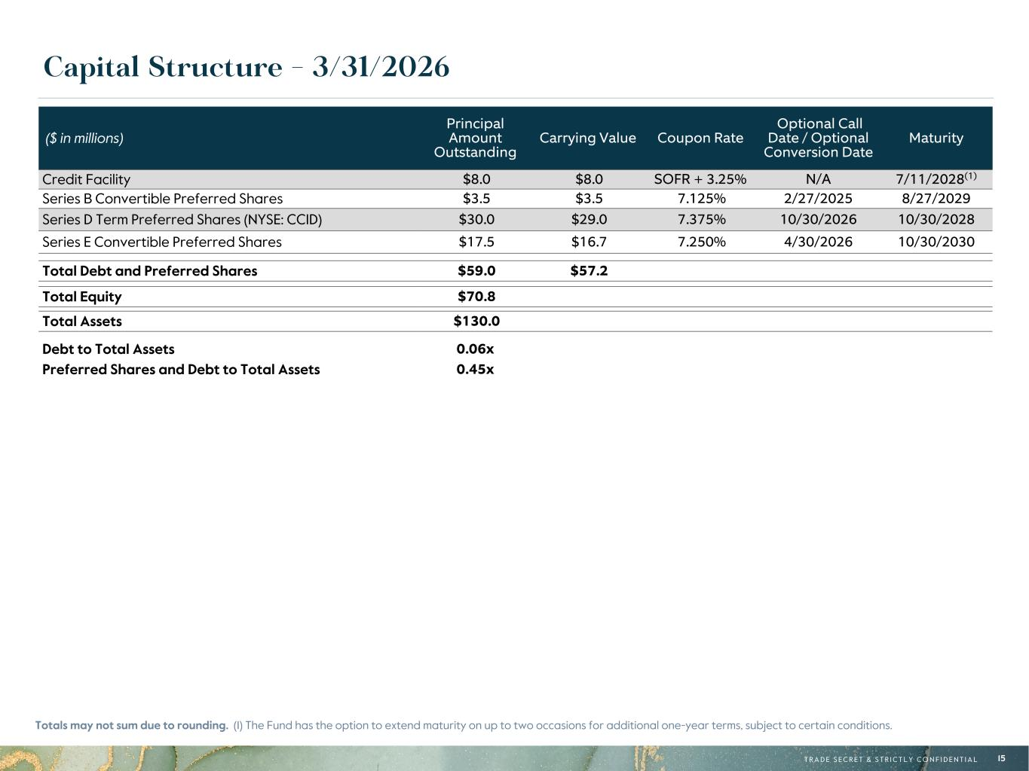
R-171, G-132, B-51 R-108, G-132, B-156 R-97, G-161, B-224 R-10, G-54, B-74 R-29, G-101, B-113 R-182, G-231, B-250 R-215, G-185, B-122 R-196, G-206, B-215 R-171, G-202, B-243 R-13, G-107, B-147 R-33, G-152, B-172 R-208, G-232, B-248 R-0, G-0, B-0 R-95, G-95, B-95 R-188, G-188, B-188 R-235, G-235, B-235 R-242, G-232, B-211 R-196, G-234, B-240 T R A D E S E C R E T & S T R I C T L Y C O N F I D E N T I A L 15 Capital Structure - 3/31/2026 Totals may not sum due to rounding. (1) The Fund has the option to extend maturity on up to two occasions for additional one-year terms, subject to certain conditions. ($ in millions) Principal Amount Outstanding Carrying Value Coupon Rate Optional Call Date / Optional Conversion Date Maturity Credit Facility $8.0 $8.0 SOFR + 3.25% N/A 7/11/2028(1) Series B Convertible Preferred Shares $3.5 $3.5 7.125% 2/27/2025 8/27/2029 Series D Term Preferred Shares (NYSE: CCID) $30.0 $29.0 7.375% 10/30/2026 10/30/2028 Series E Convertible Preferred Shares $17.5 $16.7 7.250% 4/30/2026 10/30/2030 Total Debt and Preferred Shares $59.0 $57.2 Total Equity $70.8 Total Assets $130.0 Debt to Total Assets 0.06x Preferred Shares and Debt to Total Assets 0.45x

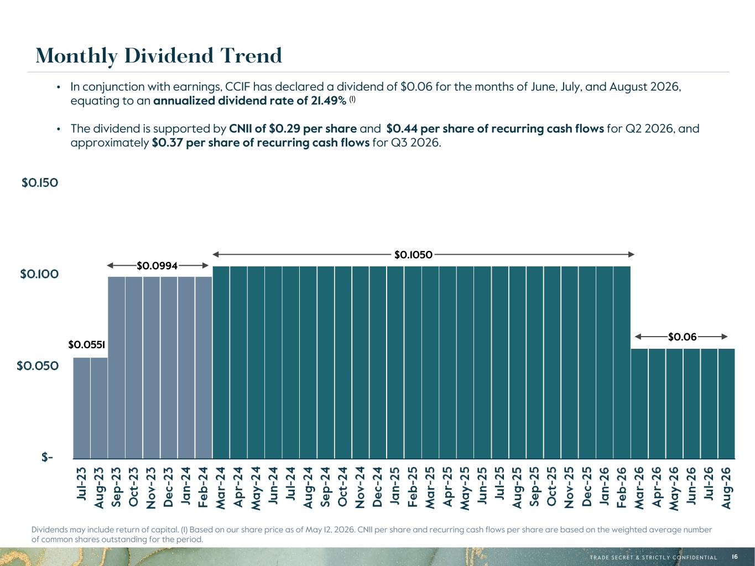
R-171, G-132, B-51 R-108, G-132, B-156 R-97, G-161, B-224 R-10, G-54, B-74 R-29, G-101, B-113 R-182, G-231, B-250 R-215, G-185, B-122 R-196, G-206, B-215 R-171, G-202, B-243 R-13, G-107, B-147 R-33, G-152, B-172 R-208, G-232, B-248 R-0, G-0, B-0 R-95, G-95, B-95 R-188, G-188, B-188 R-235, G-235, B-235 R-242, G-232, B-211 R-196, G-234, B-240 T R A D E S E C R E T & S T R I C T L Y C O N F I D E N T I A L 16 Monthly Dividend Trend Dividends may include return of capital. (1) Based on our share price as of May 12, 2026. CNII per share and recurring cash flows per share are based on the weighted average number of common shares outstanding for the period. • In conjunction with earnings, CCIF has declared a dividend of $0.06 for the months of June, July, and August 2026, equating to an annualized dividend rate of 21.49% (1) • The dividend is supported by CNII of $0.29 per share and $0.44 per share of recurring cash flows for Q2 2026, and approximately $0.37 per share of recurring cash flows for Q3 2026. $0.0994 $0.0551 $0.1050 $0.06

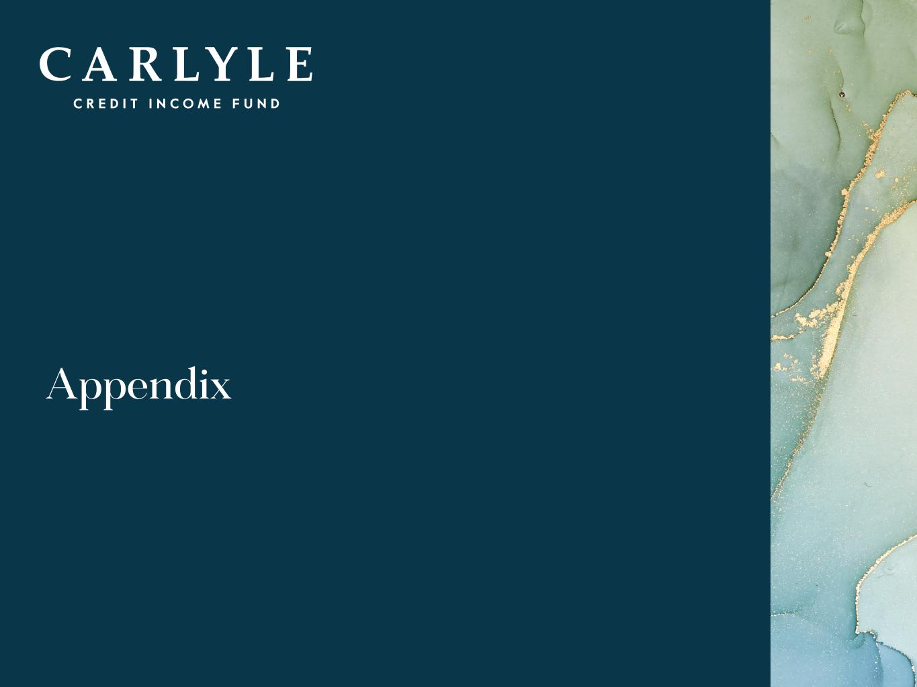
R-171, G-132, B-51 R-108, G-132, B-156 R-97, G-161, B-224 R-10, G-54, B-74 R-29, G-101, B-113 R-182, G-231, B-250 R-215, G-185, B-122 R-196, G-206, B-215 R-171, G-202, B-243 R-13, G-107, B-147 R-33, G-152, B-172 R-208, G-232, B-248 R-0, G-0, B-0 R-95, G-95, B-95 R-188, G-188, B-188 R-235, G-235, B-235 R-242, G-232, B-211 R-196, G-234, B-240 17 Appendix

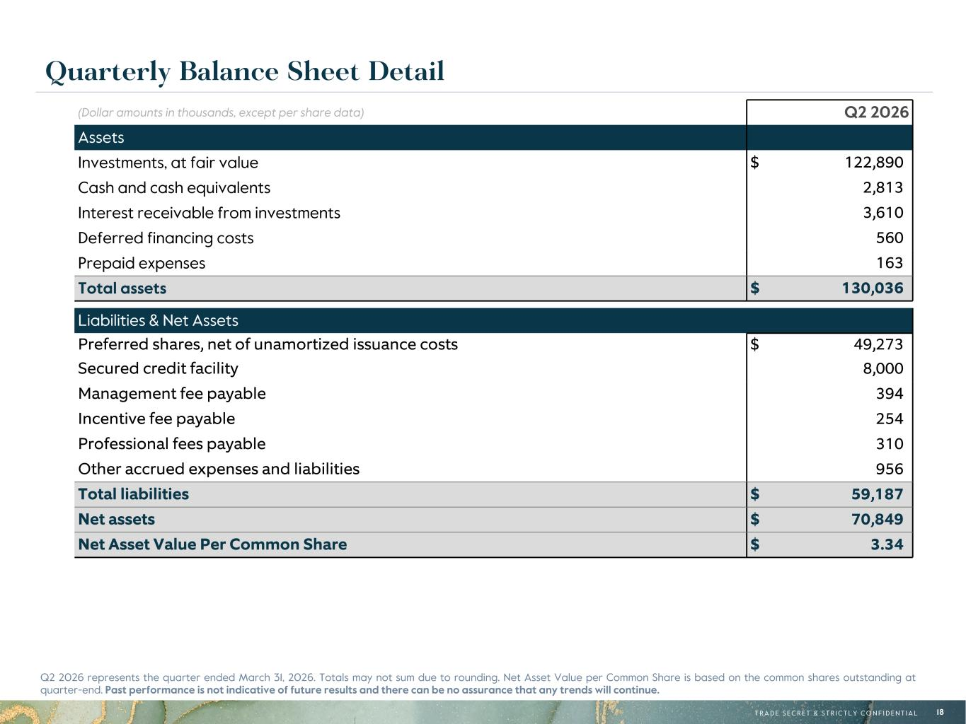
R-171, G-132, B-51 R-108, G-132, B-156 R-97, G-161, B-224 R-10, G-54, B-74 R-29, G-101, B-113 R-182, G-231, B-250 R-215, G-185, B-122 R-196, G-206, B-215 R-171, G-202, B-243 R-13, G-107, B-147 R-33, G-152, B-172 R-208, G-232, B-248 R-0, G-0, B-0 R-95, G-95, B-95 R-188, G-188, B-188 R-235, G-235, B-235 R-242, G-232, B-211 R-196, G-234, B-240 T R A D E S E C R E T & S T R I C T L Y C O N F I D E N T I A L 18 Quarterly Balance Sheet Detail (Dollar amounts in thousands, except per share data) Q2 2026 Assets Investments, at fair value $ 122,890 Cash and cash equivalents 2,813 Interest receivable from investments 3,610 Deferred financing costs 560 Prepaid expenses 163 Total assets $ 130,036 Liabilities & Net Assets Preferred shares, net of unamortized issuance costs $ 49,273 Secured credit facility 8,000 Management fee payable 394 Incentive fee payable 254 Professional fees payable 310 Other accrued expenses and liabilities 956 Total liabilities $ 59,187 Net assets $ 70,849 Net Asset Value Per Common Share $ 3.34 Q2 2026 represents the quarter ended March 31, 2026. Totals may not sum due to rounding. Net Asset Value per Common Share is based on the common shares outstanding at quarter-end. Past performance is not indicative of future results and there can be no assurance that any trends will continue.

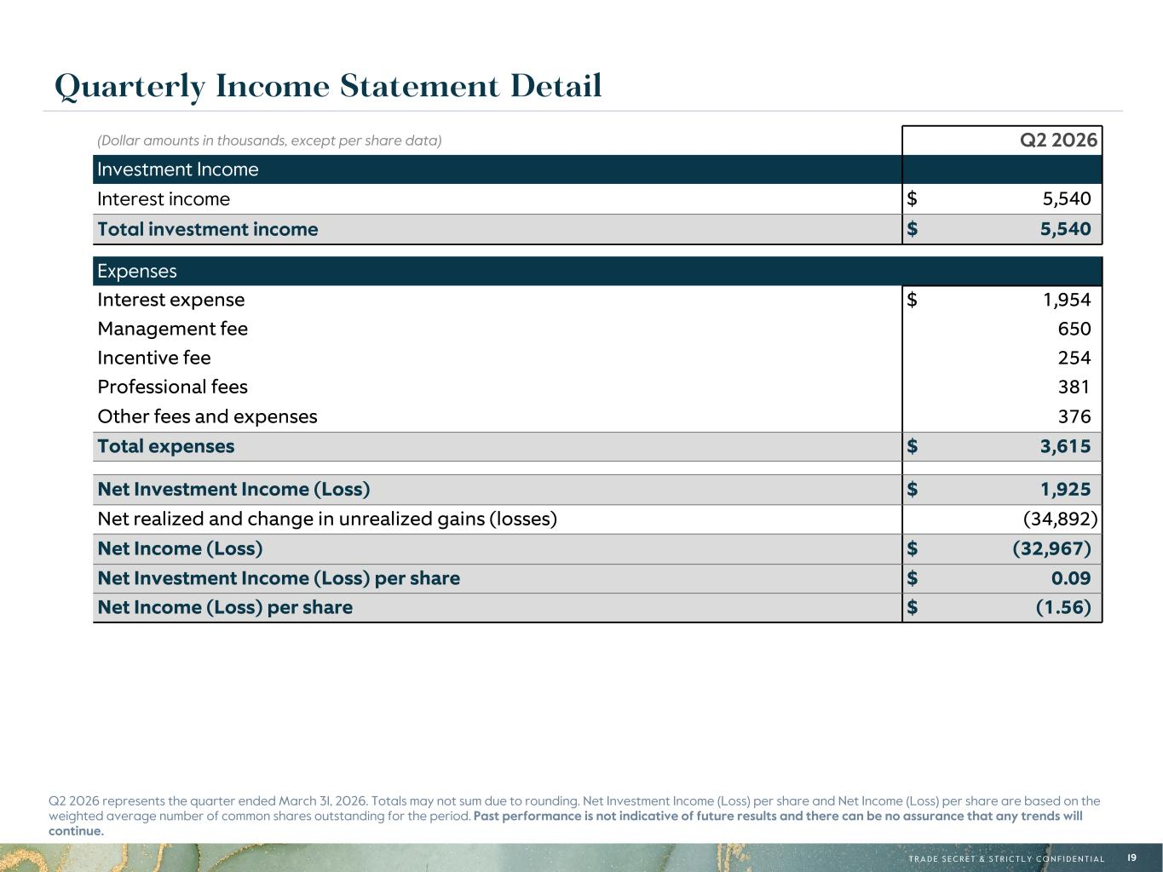
R-171, G-132, B-51 R-108, G-132, B-156 R-97, G-161, B-224 R-10, G-54, B-74 R-29, G-101, B-113 R-182, G-231, B-250 R-215, G-185, B-122 R-196, G-206, B-215 R-171, G-202, B-243 R-13, G-107, B-147 R-33, G-152, B-172 R-208, G-232, B-248 R-0, G-0, B-0 R-95, G-95, B-95 R-188, G-188, B-188 R-235, G-235, B-235 R-242, G-232, B-211 R-196, G-234, B-240 T R A D E S E C R E T & S T R I C T L Y C O N F I D E N T I A L 19 Q2 2026 represents the quarter ended March 31, 2026. Totals may not sum due to rounding. Net Investment Income (Loss) per share and Net Income (Loss) per share are based on the weighted average number of common shares outstanding for the period. Past performance is not indicative of future results and there can be no assurance that any trends will continue. Quarterly Income Statement Detail (Dollar amounts in thousands, except per share data) Q2 2026 Investment Income Interest income $ 5,540 Total investment income $ 5,540 Expenses Interest expense $ 1,954 Management fee 650 Incentive fee 254 Professional fees 381 Other fees and expenses 376 Total expenses $ 3,615 Net Investment Income (Loss) $ 1,925 Net realized and change in unrealized gains (losses) (34,892) Net Income (Loss) $ (32,967) Net Investment Income (Loss) per share $ 0.09 Net Income (Loss) per share $ (1.56)

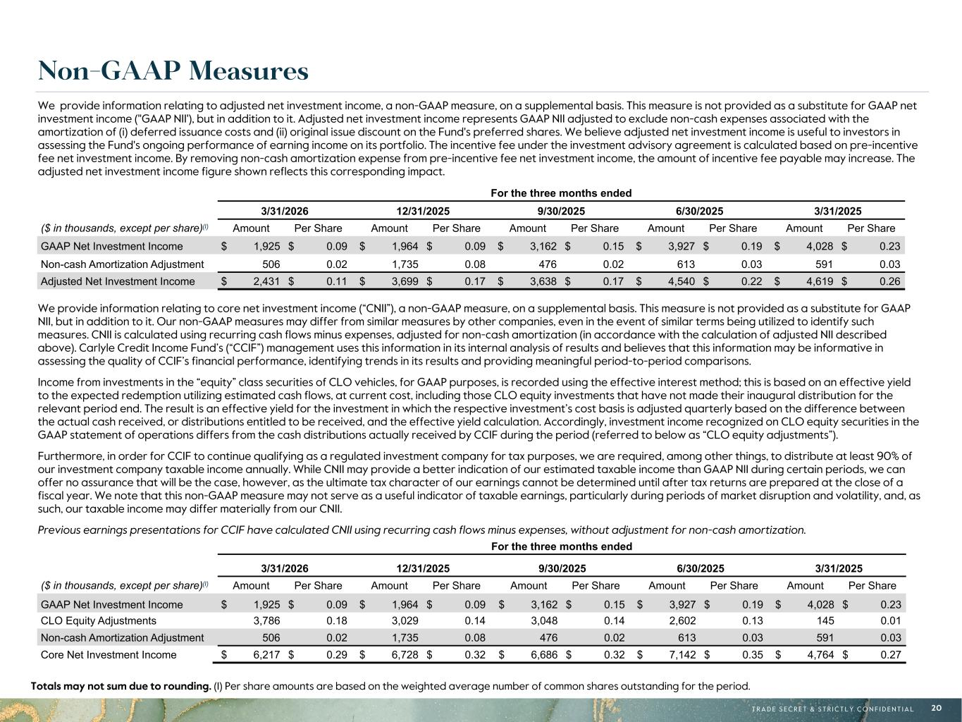
R-171, G-132, B-51 R-108, G-132, B-156 R-97, G-161, B-224 R-10, G-54, B-74 R-29, G-101, B-113 R-182, G-231, B-250 R-215, G-185, B-122 R-196, G-206, B-215 R-171, G-202, B-243 R-13, G-107, B-147 R-33, G-152, B-172 R-208, G-232, B-248 R-0, G-0, B-0 R-95, G-95, B-95 R-188, G-188, B-188 R-235, G-235, B-235 R-242, G-232, B-211 R-196, G-234, B-240 T R A D E S E C R E T & S T R I C T L Y C O N F I D E N T I A L 20 Non-GAAP Measures We provide information relating to core net investment income (“CNII”), a non-GAAP measure, on a supplemental basis. This measure is not provided as a substitute for GAAP NII, but in addition to it. Our non-GAAP measures may differ from similar measures by other companies, even in the event of similar terms being utilized to identify such measures. CNII is calculated using recurring cash flows minus expenses, adjusted for non-cash amortization (in accordance with the calculation of adjusted NII described above). Carlyle Credit Income Fund’s (“CCIF”) management uses this information in its internal analysis of results and believes that this information may be informative in assessing the quality of CCIF’s financial performance, identifying trends in its results and providing meaningful period-to-period comparisons. Income from investments in the “equity” class securities of CLO vehicles, for GAAP purposes, is recorded using the effective interest method; this is based on an effective yield to the expected redemption utilizing estimated cash flows, at current cost, including those CLO equity investments that have not made their inaugural distribution for the relevant period end. The result is an effective yield for the investment in which the respective investment’s cost basis is adjusted quarterly based on the difference between the actual cash received, or distributions entitled to be received, and the effective yield calculation. Accordingly, investment income recognized on CLO equity securities in the GAAP statement of operations differs from the cash distributions actually received by CCIF during the period (referred to below as “CLO equity adjustments”). Furthermore, in order for CCIF to continue qualifying as a regulated investment company for tax purposes, we are required, among other things, to distribute at least 90% of our investment company taxable income annually. While CNII may provide a better indication of our estimated taxable income than GAAP NII during certain periods, we can offer no assurance that will be the case, however, as the ultimate tax character of our earnings cannot be determined until after tax returns are prepared at the close of a fiscal year. We note that this non-GAAP measure may not serve as a useful indicator of taxable earnings, particularly during periods of market disruption and volatility, and, as such, our taxable income may differ materially from our CNII. Previous earnings presentations for CCIF have calculated CNII using recurring cash flows minus expenses, without adjustment for non-cash amortization. For the three months ended 3/31/2026 12/31/2025 9/30/2025 6/30/2025 3/31/2025 ($ in thousands, except per share)(1) Amount Per Share Amount Per Share Amount Per Share Amount Per Share Amount Per Share GAAP Net Investment Income $ 1,925 $ 0.09 $ 1,964 $ 0.09 $ 3,162 $ 0.15 $ 3,927 $ 0.19 $ 4,028 $ 0.23 CLO Equity Adjustments 3,786 0.18 3,029 0.14 3,048 0.14 2,602 0.13 145 0.01 Non-cash Amortization Adjustment 506 0.02 1,735 0.08 476 0.02 613 0.03 591 0.03 Core Net Investment Income $ 6,217 $ 0.29 $ 6,728 $ 0.32 $ 6,686 $ 0.32 $ 7,142 $ 0.35 $ 4,764 $ 0.27 We provide information relating to adjusted net investment income, a non-GAAP measure, on a supplemental basis. This measure is not provided as a substitute for GAAP net investment income ("GAAP NII'), but in addition to it. Adjusted net investment income represents GAAP NII adjusted to exclude non-cash expenses associated with the amortization of (i) deferred issuance costs and (ii) original issue discount on the Fund's preferred shares. We believe adjusted net investment income is useful to investors in assessing the Fund's ongoing performance of earning income on its portfolio. The incentive fee under the investment advisory agreement is calculated based on pre-incentive fee net investment income. By removing non-cash amortization expense from pre-incentive fee net investment income, the amount of incentive fee payable may increase. The adjusted net investment income figure shown reflects this corresponding impact. For the three months ended 3/31/2026 12/31/2025 9/30/2025 6/30/2025 3/31/2025 ($ in thousands, except per share)(1) Amount Per Share Amount Per Share Amount Per Share Amount Per Share Amount Per Share GAAP Net Investment Income $ 1,925 $ 0.09 $ 1,964 $ 0.09 $ 3,162 $ 0.15 $ 3,927 $ 0.19 $ 4,028 $ 0.23 Non-cash Amortization Adjustment 506 0.02 1,735 0.08 476 0.02 613 0.03 591 0.03 Adjusted Net Investment Income $ 2,431 $ 0.11 $ 3,699 $ 0.17 $ 3,638 $ 0.17 $ 4,540 $ 0.22 $ 4,619 $ 0.26 Totals may not sum due to rounding. (1) Per share amounts are based on the weighted average number of common shares outstanding for the period.

